**PRACTICAL 1**

**AIM: DDL operations on Relational Schema.**

**Create table for Salesman, Customer, Orders.**

create table salesman(

salesman_id INT NOT NULL AUTO_INCREMENT PRIMARY KEY,

name VARCHAR(100) NOT NULL,

city VARCHAR(100) NOT NULL,

commission DECIMAL(10,2)

);

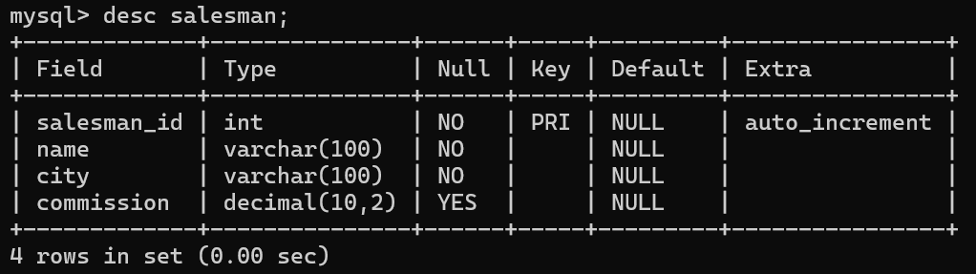

create table customer(

customer_id INT AUTO_INCREMENT PRIMARY KEY,

customer_name VARCHAR(100) NOT NULL,

city VARCHAR(100) NOT NULL,

grade INT,

salesman_id INT,

FOREIGN KEY(salesman_id) REFERENCES salesman(salesman_id)

);

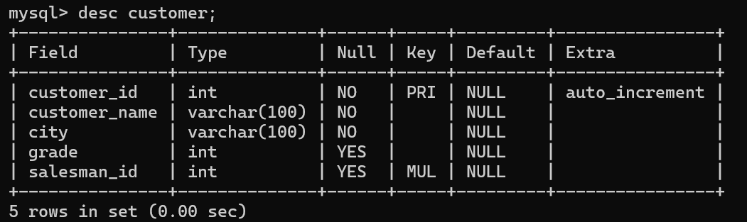

create table orders(

order_no INT AUTO_INCREMENT PRIMARY KEY,

purch_amt DECIMAL(10,2) NOT NULL,

order_date DATE NOT NULL,

customer_id INT,

salesman_id INT,

FOREIGN KEY(customer_id) REFERENCES customer(customer_id),

FOREIGN KEY(salesman_id) REFERENCES salesman(salesman_id)

);

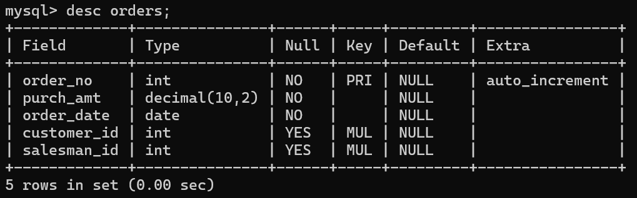

**Values of salesman**

insert into salesman values(5001, 'James Hoog', 'New York', 0.15);

insert into salesman values(5002, 'Nail Knite', 'Paris', 0.13);

insert into salesman values(5005, 'Pit Alex', 'London', 0.11);

insert into salesman values(5006, 'Mc Lyon', 'Paris', 0.14);

insert into salesman values(5003, 'Lauson Hen', '', 0.12);

insert into salesman values(5007, 'Paul Adam', 'Rome', 0.13);

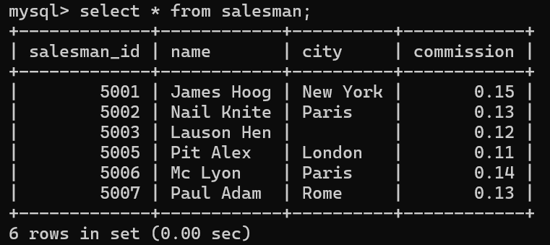

**Values of customer**

insert into customer values(3002, 'Nick Rimando', 'New York', 100, 5001);

insert into customer values(3005, 'Graham Zusi', 'California', 200, 5002);

insert into customer values(3001, 'Brad Guzan', 'Londan', 100, 5005);

insert into customer values(3004, 'Fabian Johns', 'Paris', 300, 5006);

insert into customer values(3007, 'Brad Davis', 'New York', 200, 5001);

insert into customer values(3009, 'Geoff Camero', 'Berlin', 100, 5003);

insert into customer values(3008, 'Julian Green', 'London', 300, 5002);

insert into customer values(3003, 'Jory Altidor', 'Moncow', 200, 5007);

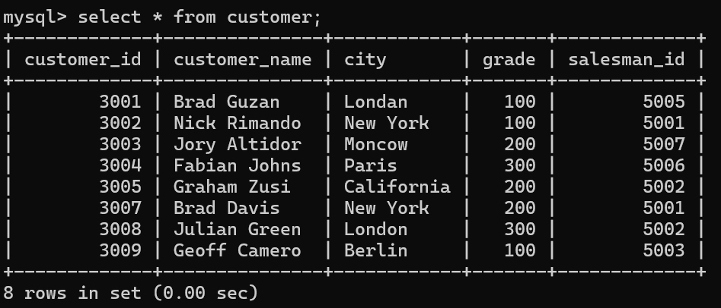

**Values of customer**

insert into orders values(70001, 150.5, '2016-10-05', 3005, 5002);

insert into orders values(70009, 270.65, '2016-09-10', 3001, NULL);

insert into orders values(70002, 65.26, '2016-10-05', 3002, 5001);

insert into orders values(70004, 110.5, '2016-08-17', 3009, NULL);

insert into orders values(70007, 948.5, '2016-09-10', 3005, 5002);

insert into orders values(70005, 2400.6, '2016-07-27', 3007, 5001);

insert into orders values(70008, 5760, '2016-09-10', 3002, 5001);

insert into orders values(70010, 1983.43, '2016-10-10', 3004, NULL);

insert into orders values(70003, 2480.4, '2016-10-10', 3009, 5006);

insert into orders values(70012, 250.45, '2016-06-27', 3008, 5002);

insert into orders values(70011, 75.29, '2016-08-17', 3003, 5007);

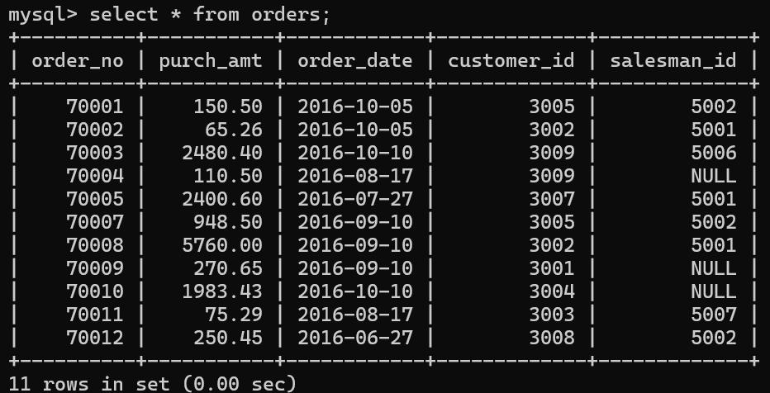

1. **Display name and commission for all the salesmen.**

select name,commission from salesman;

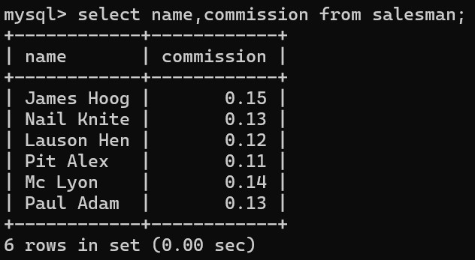

1. **Retrieve salesman id of all salesmen from orders table without any repeats.**

select DISTINCT salesman_id from orders;

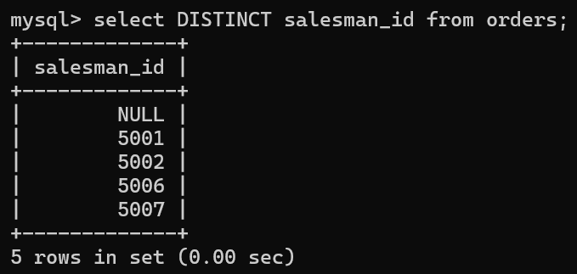

1. **Display names and city of salesman, who belongs to the city of Paris.**

select name,city from salesman where city='Paris';

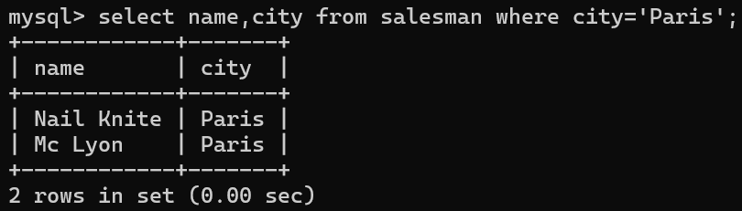

1. **Display all the information for those customers with a grade of 200.**

select * from customer where grade='200';

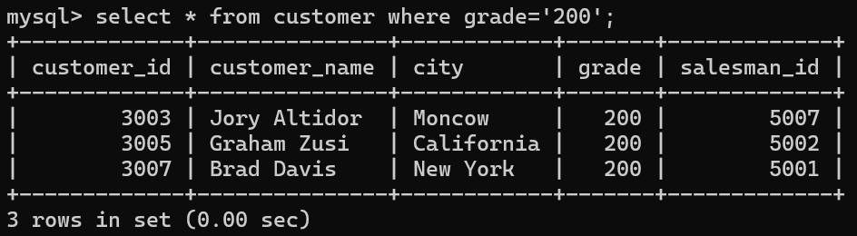

1. **Display the order number, order date and the purchase amount for order(s) which will be delivered by the salesman with ID 5001.**

select order_no,purch_amt,order_date from orders where salesman_id='5001';

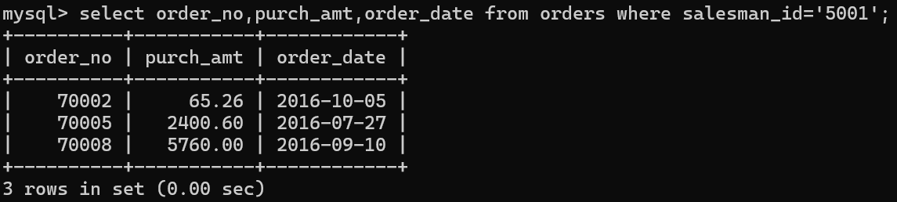

1. **Display all the customers, who are either belongs to the city New York or not had a grade above 100.**

select * from customer where city='New York' OR grade<=100;

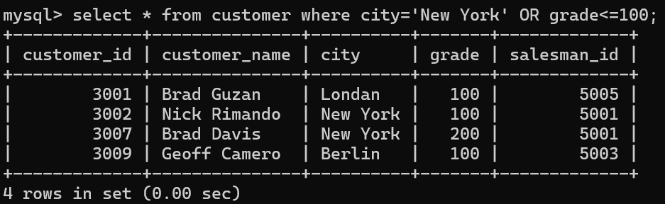

1. **Find those salesmen with all information who gets the commission within a range of 0.12 and 0.14.**

select * from salesman where commission BETWEEN 0.12 AND 0.14;

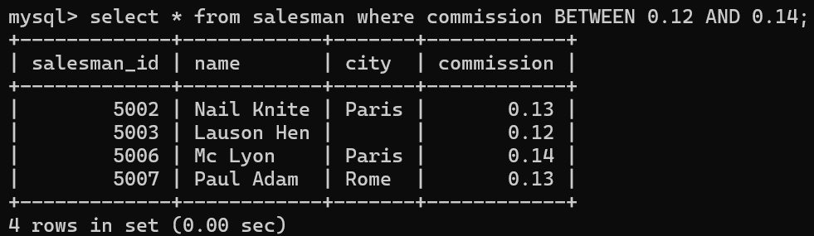

1. **Find all those customers with all information whose names are ending with the letter 'n'.**

select * from customer where customer_name LIKE '%n';

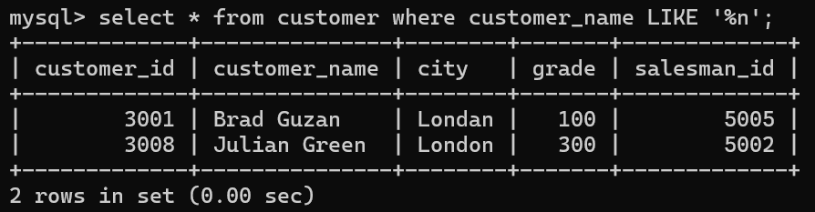

1. **Find those salesmen with all information whose name containing the 1st character is 'N' and the 4th character is 'l' and rests may be any character.**

select * FROM salesman WHERE name LIKE 'N_i%';

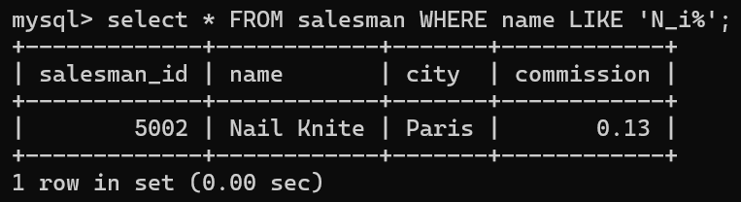

1. **Find that customer with all information who does not get any grade except NULL.**

select * from customer where grade is NULL;



1. **Find the total purchase amount of all orders.**

select sum(purch_amt) AS total_purchase from orders;

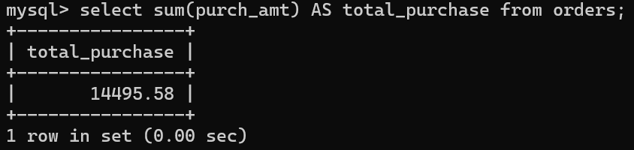

1. **Find the number of salesman currently listing for all of their customers.**

select salesman_id,COUNT(customer_id) as total_customers from customer GROUP BY salesman_id;

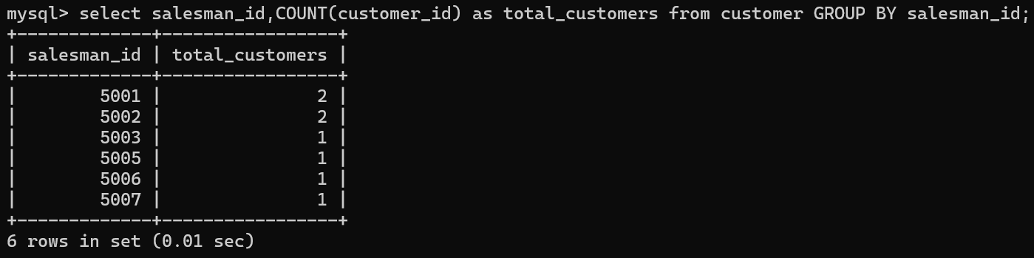

1. **Find the highest grade for each of the cities of the customers.**

select city, max(grade) As highest_grade from customer GROUP BY city;

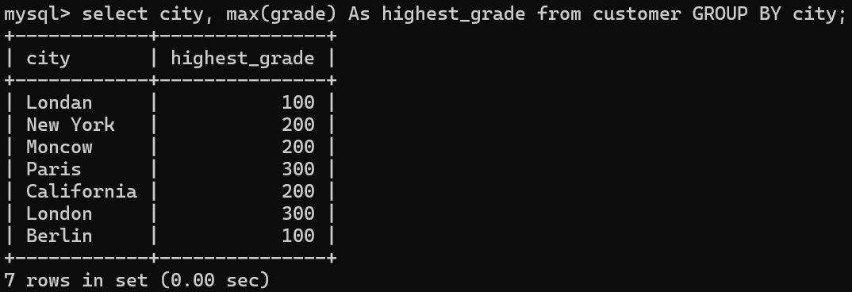

1. **Find the highest purchase amount ordered by each customer with their ID and highest purchase amount.**

select customer_id, max(purch_amt) AS highest_purchase from orders GROUP BY customer_id;

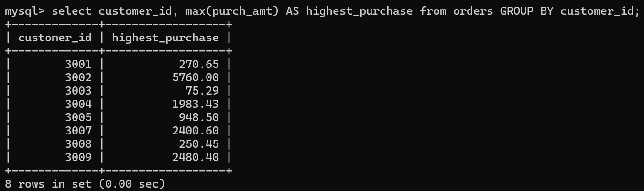

1. **Find the highest purchase amount ordered by each customer on a particular date with their ID, order date and highest purchase amount.**

select customer_id,order_date,max(purch_amt) as highest_purchase from orders GROUP BY customer_id,order_date;

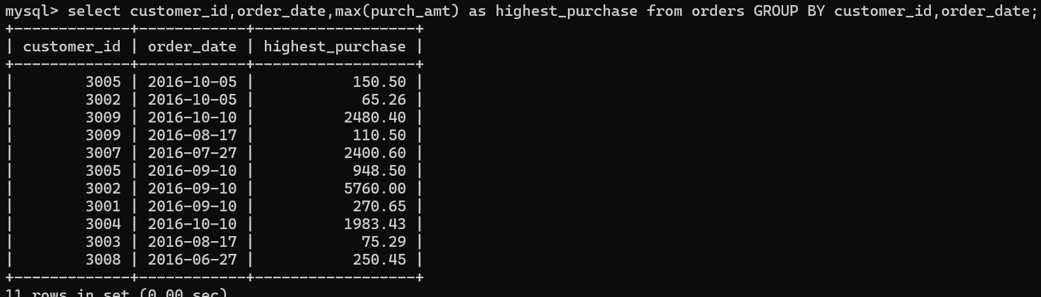

1. **Find the highest purchase amount on a date '2012-08-17' for each salesman with their ID.**

select salesman_id,max(purch_amt) as highest_purchase from orders where order_date='2012-08-17' GROUP BY salesman_id;



1. **Find the highest purchase amount with their customer ID and order date, for only those customers who have the highest purchase amount in a day is more than 2000.**

select customer_id,order_date,max(purch_amt) as highest_purchase from orders GROUP BY customer_id,order_date HAVING max(purch_amt)>2000;

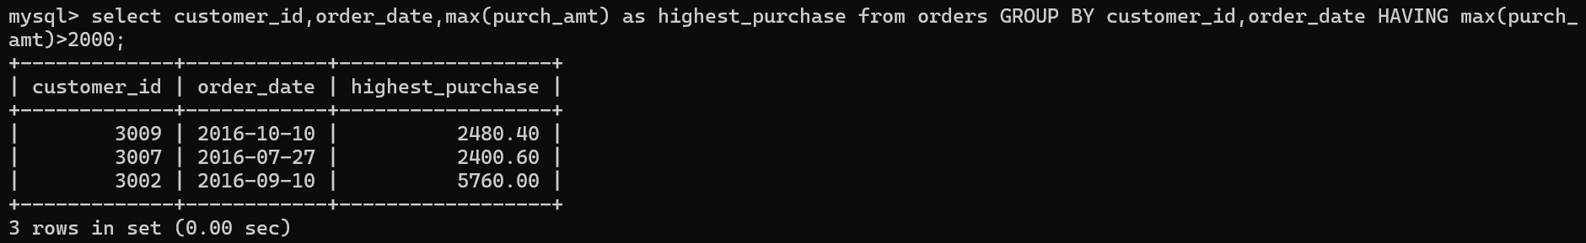

1. **Write a SQL statement that counts all orders for a date August 17th, 2012.**

select COUNT(*) as total_orders from orders where order_date='2012-08-17';

